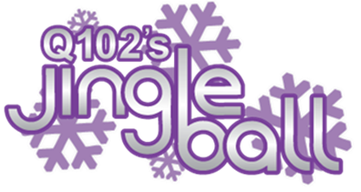

Q102 & Joe Jonas Present Check to Children's Hospital The Voice Program on Behalf of the Ryan Seacrest Foundation During Jingle Ball 2011

Who: Q102 and the Ryan Seacrest Foundation.

What: Joe Jonas will present a check for more than $15,000.00 on behalf of the Ryan Seacrest Foundation to the Children's Hospital of Philadelphia Voice Program. $1.00 from each ticket to Q102's Jingle Ball contributed to the donation.

When: Wednesday December 7, 2011 at 7:45 PM

Where: The Lexus Club in the Wells Fargo Center during Q102's Jingle Ball.

Details: The Ryan Seacrest Foundation (RSF) is a non-profit 501(c)(3) organization dedicated to enhancing the quality of life for seriously ill and injured children through unique programs that utilize multimedia and interactive platforms to enlighten, entertain and educate. RSF's first initiative is to build broadcast media centers, named THE VOICE within pediatric hospitals including Children's Hospital of Philadelphia for patients to explore the creative realms of radio, television and new media. RSF's aim is to contribute positively to the healing process for children and their families during their stay by developing these centers to bring an uplifting spirit to the hospital community. For more info go to http://ryanseacrestfoundation.org/about/

Visuals: Joe Jonas presenting check to Children's Hospital and children participating in The Voice Program.

For more information call Loraine Ballard Morrill at 484-437-0378 (cell)

Loraine Ballard Morrill
News and Community Affairs Director
Clear Channel Radio Philadelphia
111 Presidential Blvd. Suite 100
Bala Cynwyd, PA 19004
610-784-5255
WUSL FM - WDAS FM - WIOQ FM - WISX FM - WRFF FM - WDAS AM

